SYT FRX04 Force sensor max hits during Pick RxFAU

Week1:
- Time Range: 2022-09-28 23:00:00 - 2022-10-05 23:00:00
- Max hits: 61
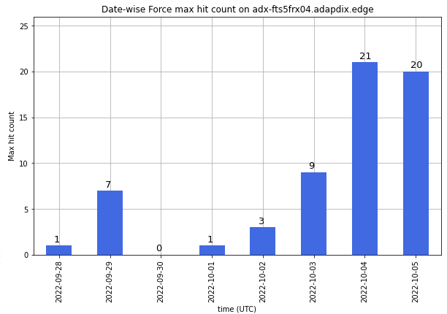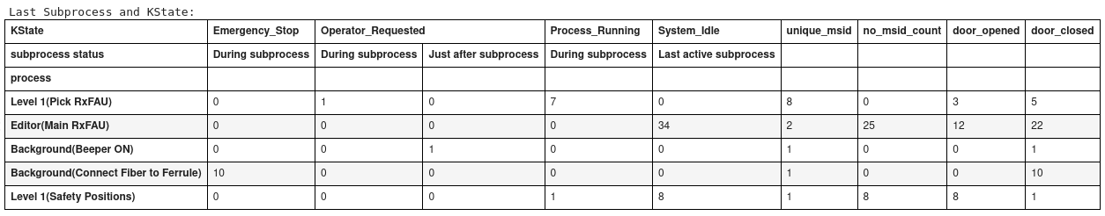
MSIDs for Max Hit during Pick RxFAU with door closed
PJFR223839S9P
PJFR22383K42P
PJFR223841H8P
PJFR223845C1P
PJFR223858N7P

Week 2:
- Date Range: 2022-09-21 00:00:00 - 2022-09-27 23:59:59(UTC)
- #Max hits: 52
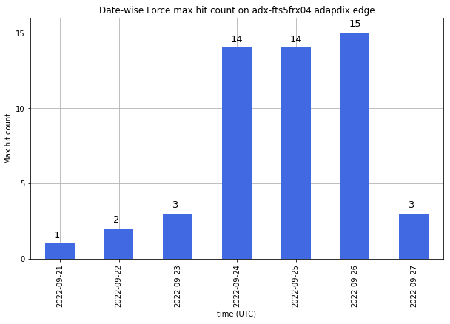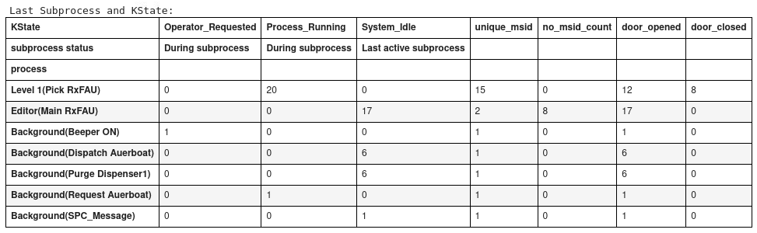
MSIDs for Max Hit during Pick RxFAU with door closed
PJFR22377304P
PJFR223774N5P
PJFR223810N1P
PJFR22381Z61P

